

**EVENT MANAGEMENT SYSTEM**

**Software Requirement Specification**

**-Group 5-**

**Tôn Trọng Nghĩa**

**Trần Nguyễn Khôi Nguyên**

**Lê Minh Khoa**

-Ho Chi Minh City, November 2021-

**Table of Contents**

I. Overview 4

1. Introduction 4

2. System Functions 5

II. Functional Requirements 7

1. Login and Register account……………………………………………………………………………………………….7

a. Login…………………………………………………………………………………………………………………….7

b. Register account…………………………………………………………………………………………………..8

2. Search Event……………………………………………………………………………………………………………………..8

a. Search Event with Name………………………………………………………………………………………8

b. Search Event with Category………………………………………………………………………………….9

3. View Event’s Details…………………………………………………………………………………………………………10

a. Show event details………………………………………………………………………………………………10

4. Follow Event…………………………………………………………………………………………………………………….11

a. Follow event……………………………………………………………………………………………………. 11

b. Unfollow event……………………………………………………………………………………..………………12

c. View followed event………………………………………………………………………………………………13

5. Register Event…………………………………………………………………………………………………………………..14

a. Register event………………………………………………………………………………………………….……14

b. View registered event………………………………………………………………………………………………15

6. Question and Answer………………………………………………………………………………………………………….16

a. Ask question……………………………………………………………………………………………………………16

b. Answer Question………………………………………………………………………………………………………17

7. Change role………………………………………………………………………………………………………………………….18

a. Request change role………………………………………………………………………………………………..18

8. Event Management…………………………………………………………………………………………………………….19

a. Create Event………………………………………………………………………………………………………….19

b. Edit Event……………………………………………………………………………………………………..20

c. Start Event……………………………………………………………………………………………………21

d. Complete Event………………………………………………………………………………………………22

e. Cancel Event………………………………………………………………………………………………23

9. Followup Management………………………………………………………………………………………………24

a. Add Followup………………………………………………………………………………………………24

b. Edit Followup………………………………………………………………………………………………25

10. Mentor in Event Management…………………………………………………………………………………………26

a. Add Mentor………………………………………………………………………………………………26

b. Remove Mentor………………………………………………………………………………………………27

11. Particitpate in Event………………………………………………………………………………………………28

a. Request Participate………………………………………………………………………………………………28

12. Account Management………………………………………………………………………………………………29

a. Change information for account………………………………………………………………………………29

b. Ban / Unban account………………………………………………………………………………………………30

I. Overview

## 1. Introduction

The Event Management System is a system help student in FPT University follow what event that was held in the school and notify for student when an event that they interested in has some changes. The sysem expected to improve over some releases, finally can deploy it to a server and notify for student with e-mail.

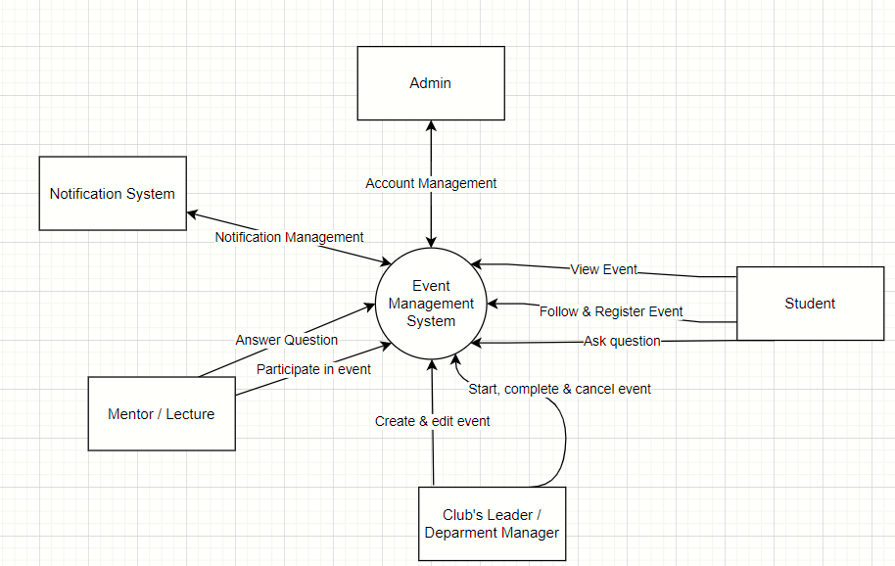

## 2. System Functions

#### a. Screen Flow

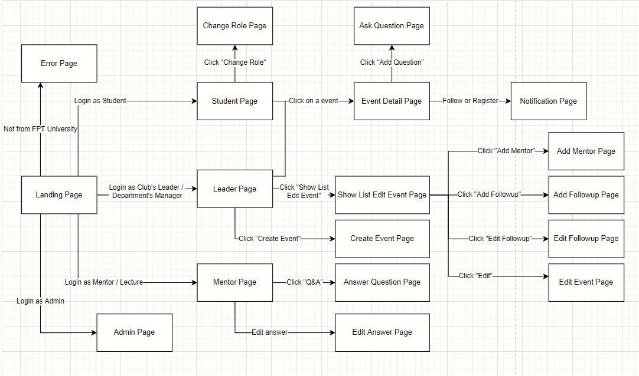

#### b. Screen Details

|  |  |  |  |
| --- | --- | --- | --- |
| # | Feature | Screen | Description |
| 1 | Login | Landing Page | Users want to use any further feature must login with a FPT mail |
| 2 | Search Event | Student Page  Leader Page  Mentor Page | Any user is login with a role that not Admin can search to find events that being held in FPT University |
| 3 | View Event Detail | Event Detail Page | Users can click on any event that was shown in their home page to view that event’s detail |
| 4 | Follow event | Event Detail Page | Users can follow event to get notification when event’s information change |
| 5 | Register event | Event Detail Page | Users can register in event to get a seat when event started |
| 6 | View Followup | Event Detail Page | Users can view event’s followup information |
| 7 | Ask Question | Ask Question Page | Users can ask question about event for event’s mentor |
| 8 | View followed / registered event | Notification Page | Users can view events that they have followed / registered |
| 9 | Request Change role | Change Role Page | Users can send request to change their role |
| 10 | Create Event | Create Event Page | Club’s Leader and Department’s Manager can create a new event. |
| 11 | Start Event | Show List Edit Event Page | Club’s Leader and Department’s Manager can start an event that was create by them. |
| 12 | Cancel Event | Show List Edit Event Page | Club’s Leader and Department’s Manager can cancel an event that was create by them. |
| 13 | Edit Event | Edit Event Page | Club’s Leader and Department’s Manager can chage the information of an event that was create by them. |
| 14 | Add Followup | Add Followup Page | Club’s Leader and Department’s Manager can add followup for an event that was create by them. |
| 15 | Edit Followup | Edit Followup Page | Club’s Leader and Department’s Manager can edit followup for an event that was create by them. |
| 16 | Add Mentor | Add Mentor Page | Club’s Leader and Department’s Manager can add mentor for an event that was create by them. |
| 17 | Remove Mentor | Add Mentor Page | Club’s Leader and Department’s Manager can remove mentor for an event that was create by them. |
| 18 | Answer Question | Aswer Question Page | Mentor can answer question that was ask about the event that they participated in |
| 19 | Paritcipated in event | Event Detail Page | Mentor can request to participated in an event to help answer question |
|  | Account Management | Admin Page | Admin can change information, ban, unban users’ account |

#### c. User Authorization

|  |  |  |  |  |  |
| --- | --- | --- | --- | --- | --- |
| Screen | Student | Club’s Leader /  Department’s Manager | Mentor / Lecture | Admin | Guest |
| Landing Page | X | X | X | X | X |
| Login | X | X | X | X | X |
| Home Page | X | X | X | X |  |
| Search Event | X | X | X |  |  |
| Student Page | X |  |  |  |  |
| Leader Page |  | X |  |  |  |
| Mentor Page |  |  | X |  |  |
| Admin Page |  |  |  | X |  |
| Event Detail Page | X | X | X |  |  |
| Follow Event | X | X | X |  |  |
| Register Event | X | X |  |  |  |
| Participate in Event |  |  | X |  |  |
| Ask Question Page | X | X | X |  |  |
| Notification Page | X | X | X |  |  |
| Change Role Page | X | X | X |  |  |
| Create Event Page |  | X |  |  |  |
| Edit Event Page |  | X |  |  |  |
| Add / Edit Followup Page |  | X |  |  |  |
| Answer Question Page |  |  | x |  |  |
| Error Page |  |  |  |  | X |

In which:

Guest: is a user that was not login to the system

Student: Student is a basic role apply to any account that login into the system for the first time

Club’s Leader / Department’s Manager: account’s role can become Club’s Leader / Department’s Manager if Admin change them. Users can request change role at Change Role Page. This role is responsible to manage event in system.

Mentor / Lecture: account’s role can become Mentor / Lecture if Admin change them. Users can request change role at Change Role Page. This role is responsible to answer question about event.

Admin: account’s role can become Admin if Admin change them. Users can request change role at Change Role Page. This role is responsible to manage account in system.

# II. Functional Requirements

## 1. Login and Register account

a. Login

Trigger: when user click on “login with fpt mail” button a choose an email to login.

Description: this feature can be use by any user on Landing Page.

Screen Layout:

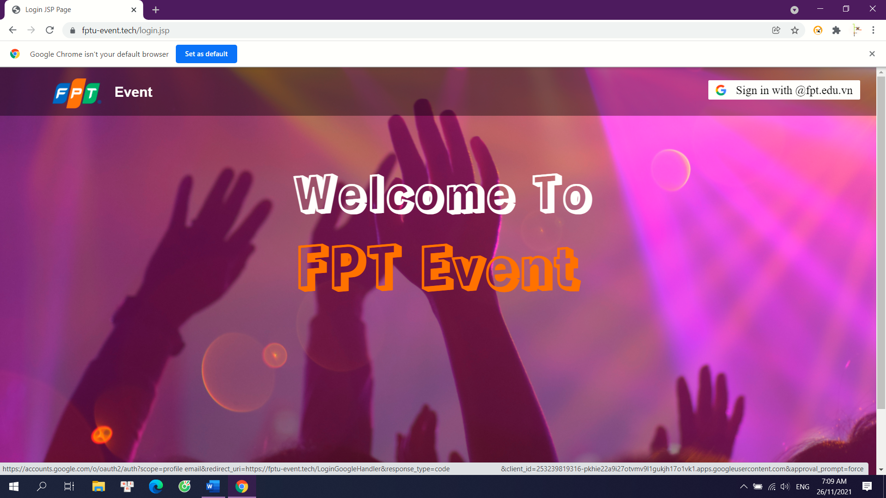

Details: the system will check if the email is from fpt. If it is, user will be move to home page depend on their role. If it is not, user will be move to Error Page which announce the that the email is not from fpt.

b. Register account

Trigger: when user use a FPT mail to login to the system for the first time.

Description: any user uses a FPT mail for the first-time login to the system will generate an account in database.

Details: the default role for the new account is Student.

## 2. Search Event

a. Search Event with Name

Trigger: when user click “search” icon.

Description: this feature can be use by any user that their role is not Admin to find a specific event.

Screen Layout:

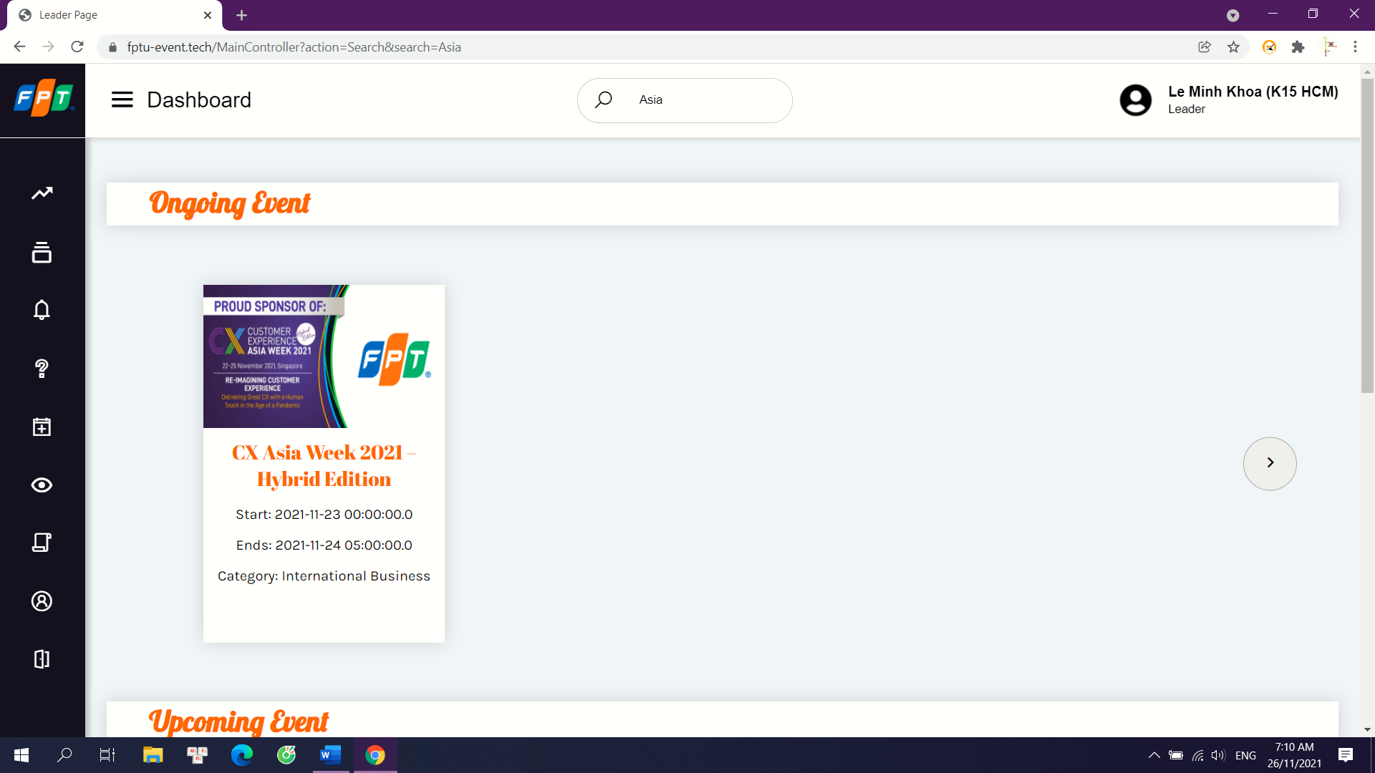

Details: system will use the input text next to the “search” button to find event that have the search text in their name.

b. Search Event with Category

Trigger: when user click any “category” button

Description: this feature can be use by any user that their role is not Admin to find events belong to a category.

Screen Layout:

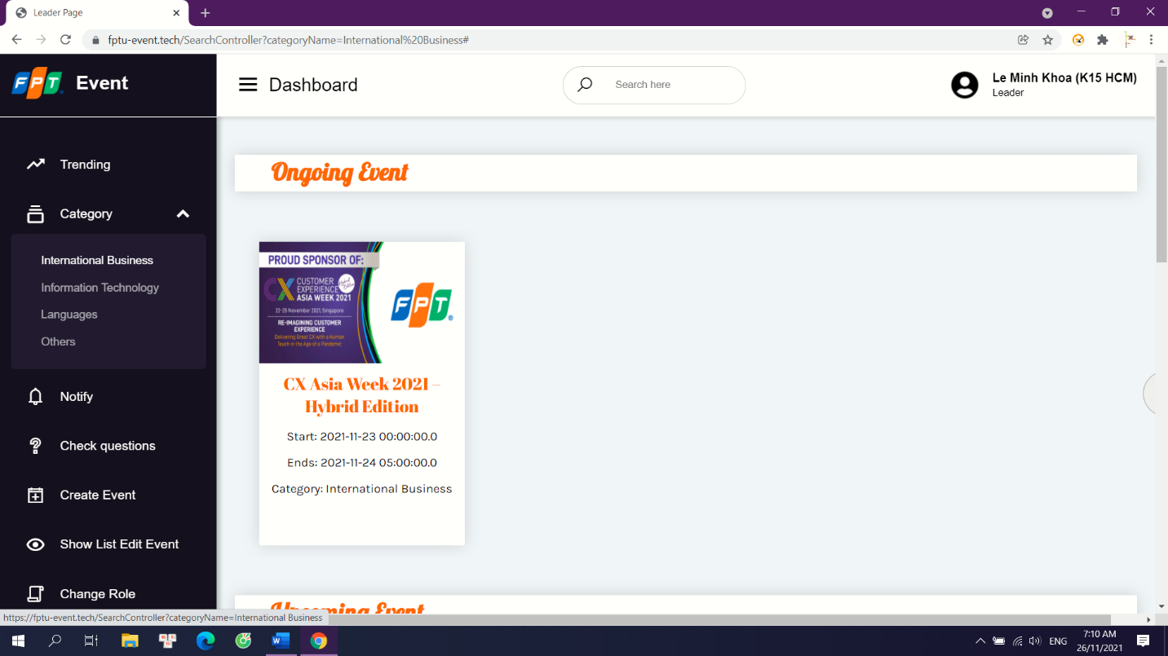

Details: system will return events that belong to that category.

## 3. View Event’s Details

a. Show event details

Trigger: when a user clicks on an event that was shown in home page.

Description: any user that their role is not Admin can view the details of an event.

Screen Layout: 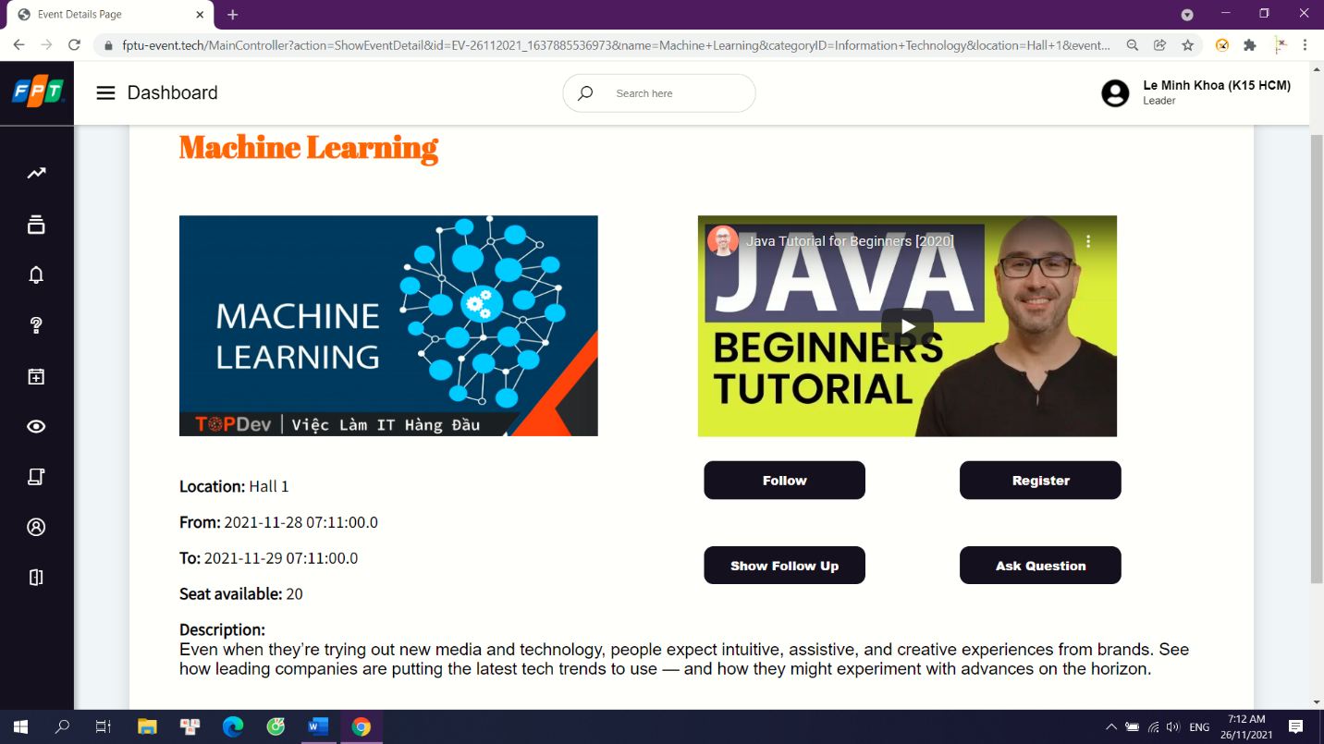

Details: system will show event’s name, details, seat, creator, start time, end time… for user so that they can know more about the event.

## 4. Follow Event

a. Follow event

Trigger: when a user clicks “follow” on an event at Event Detail Page.

Description: any user that their role is not Admin can follow any event to get notification when its information change.

Screen Layout:

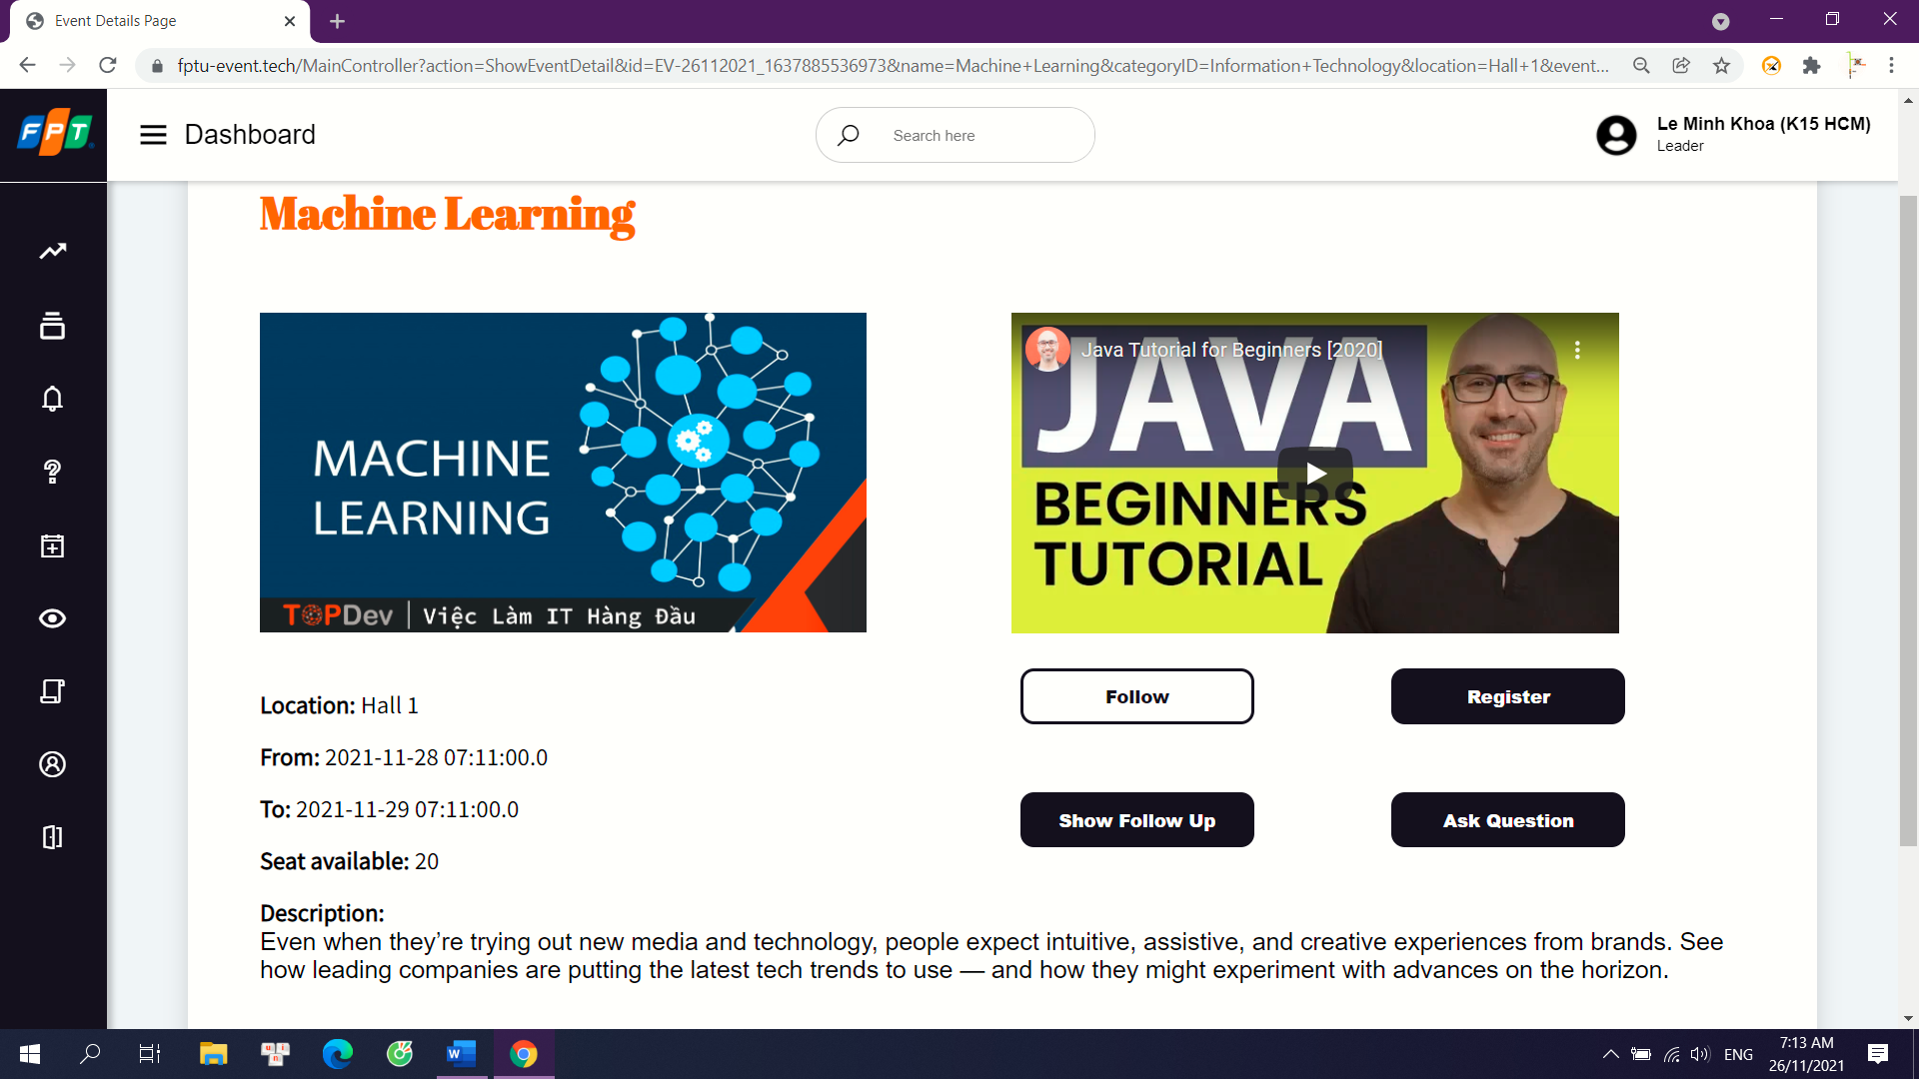

Details: system will add a new follow for the account to the event

b. Unfollow event

Trigger: when a user clicks “unfollow” on an event at Notification Page or clicks “follow” again on an event at Event Detail Page.

Description: any user that their role is not Admin can unfollow any event to stop get notification when its information change.

Screen Layout: 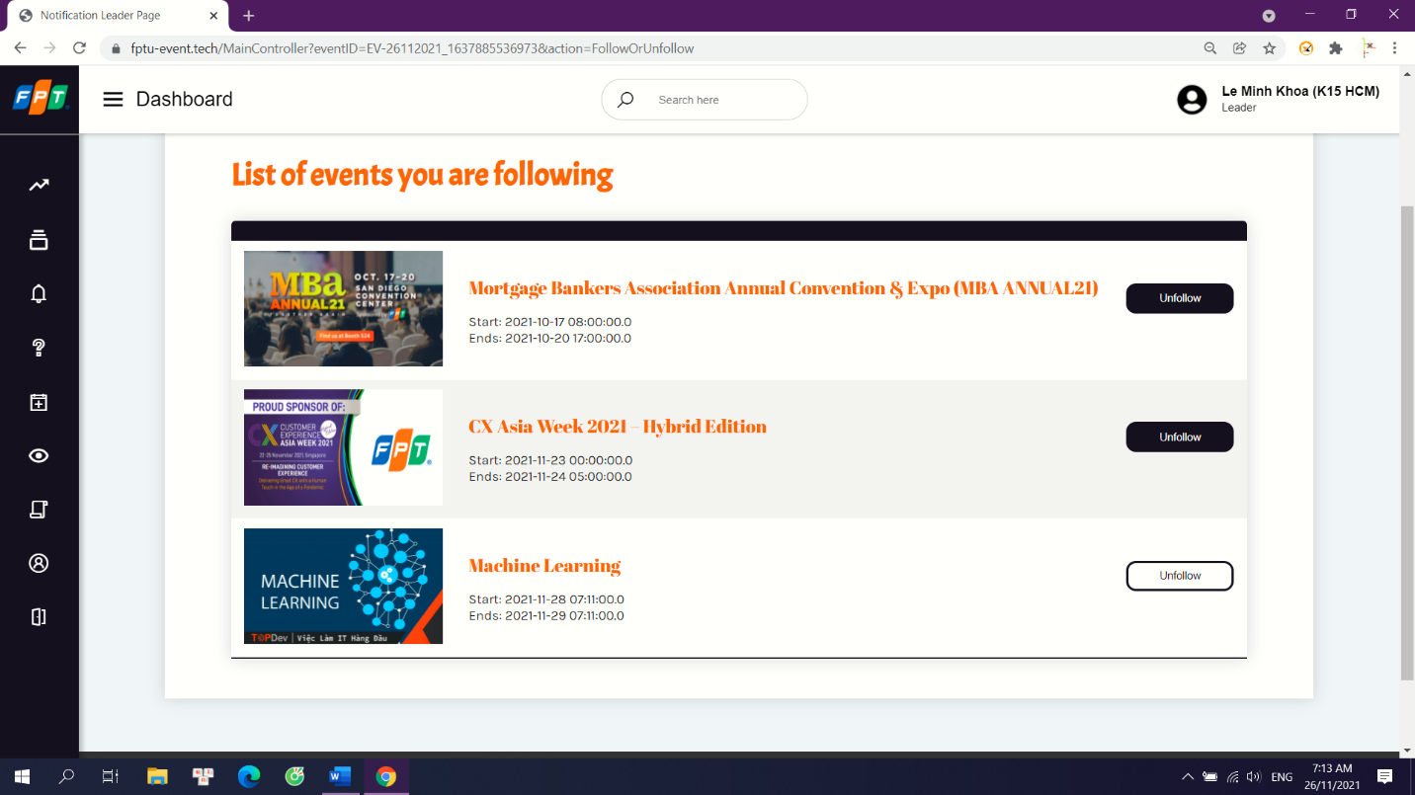

Details: system will add a new follow for the account to the event.

c. View followed event

Trigger: when a user clicks “follow” on an event at Event Detail Page or clicks “notification” button.

Description: any user that their role is not Admin view list of events that they have followed.

Screen Layout:

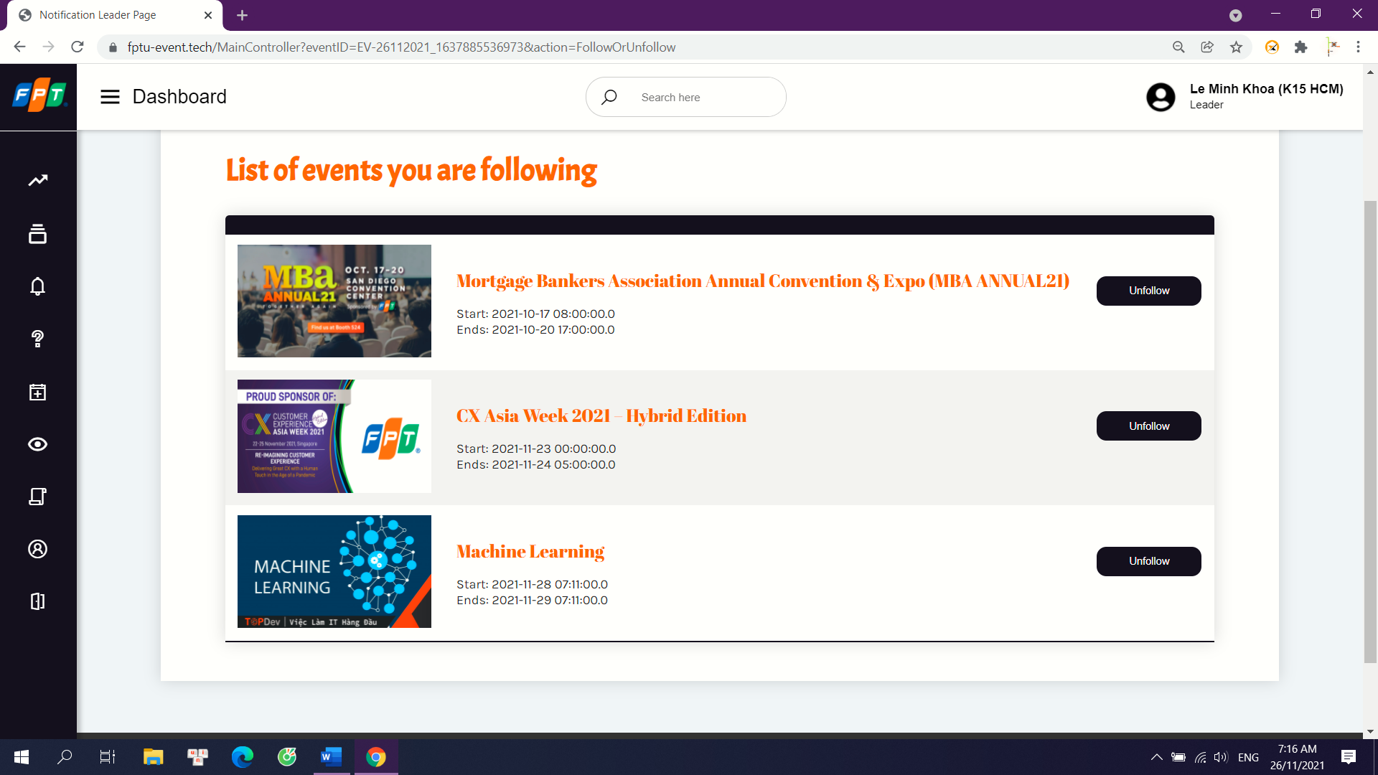

Details: system will show them the list of events that they have followed.

## 5. Register Event

a. Register event

Trigger: when a user clicks “register” on an event at Event Detail Page.

Description: any user that their role is not Admin can register to get a seat in an event.

Screen Layout:

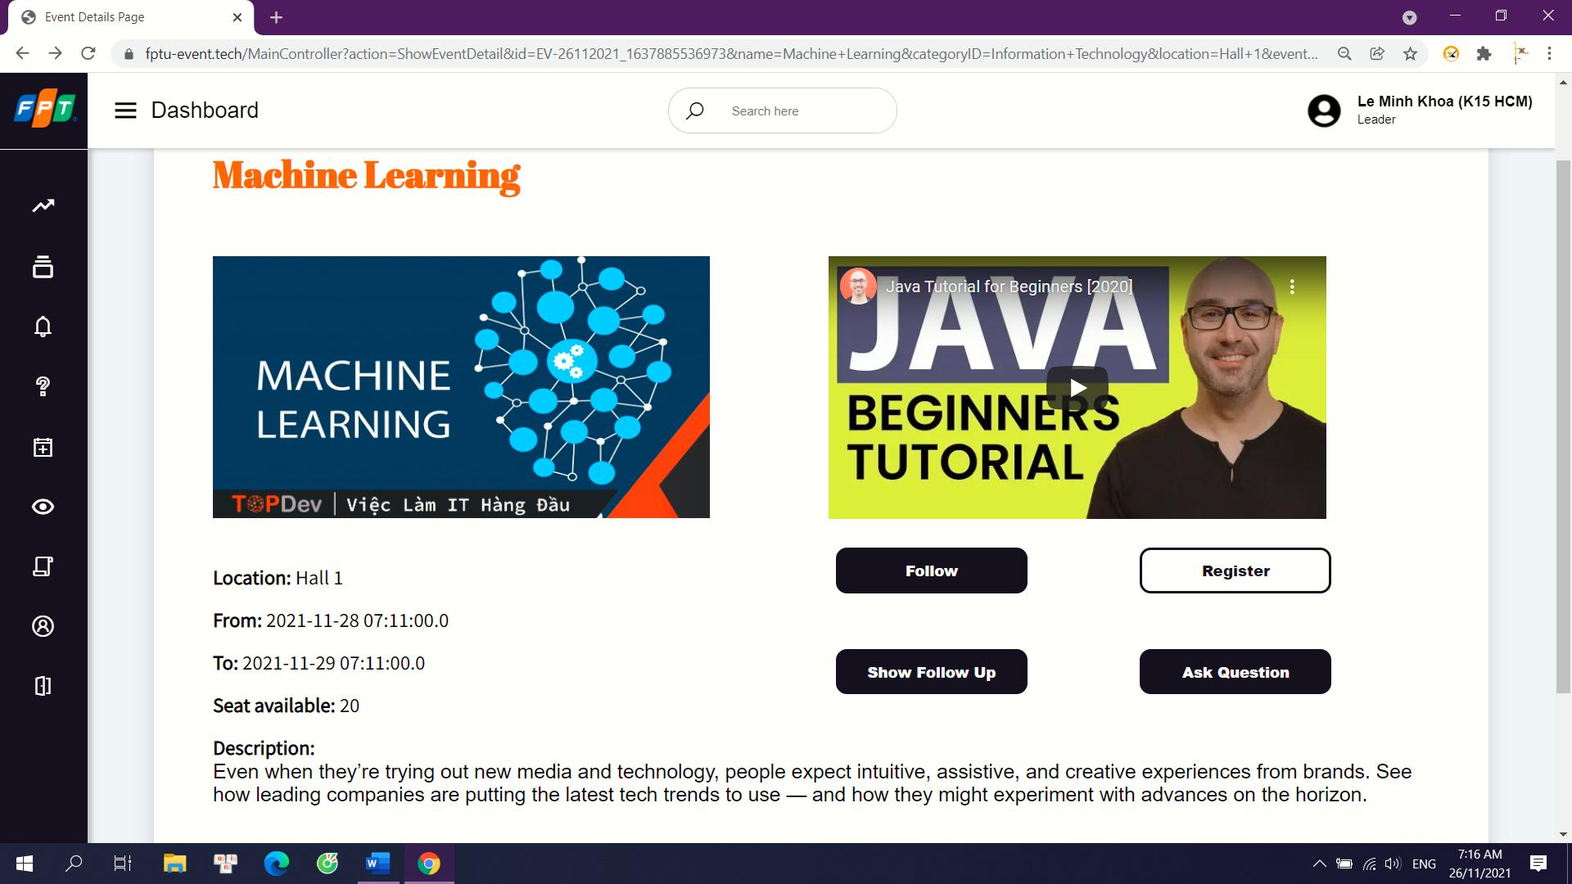

Details: system will add a new register for the account to the event

b. View registered event

Trigger: when a user clicks “register” on an event at Event Detail Page or clicks “notification” button.

Description: any user that their role is not Admin view list of events that they have registered.

Screen Layout:

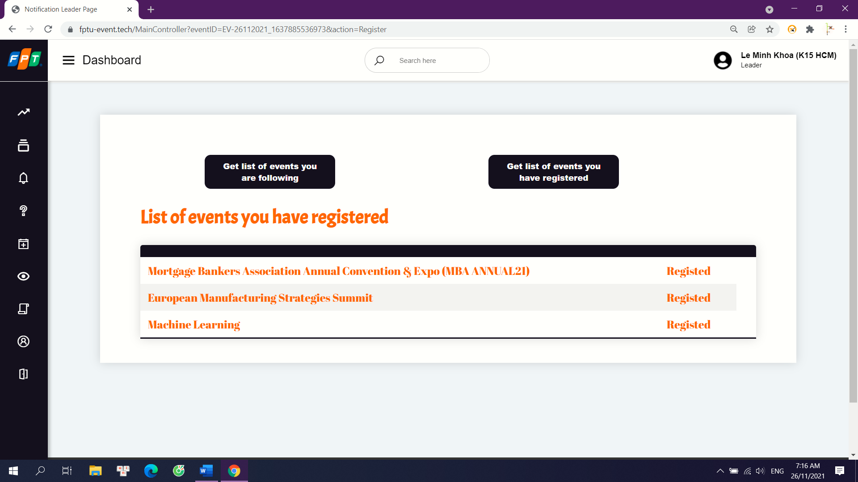

Details: system will show them the list of events that they have registered. This can use as a proof to take a seat in the event.

## 6. Question and Answer

a. Ask question

Trigger: when a user clicks “ask question” on an event at Event Detail Page.

Description: any user that their role is not Admin can ask question for mentor in Ask Question Page. User can choose which mentor to ask.

Screen Layout:

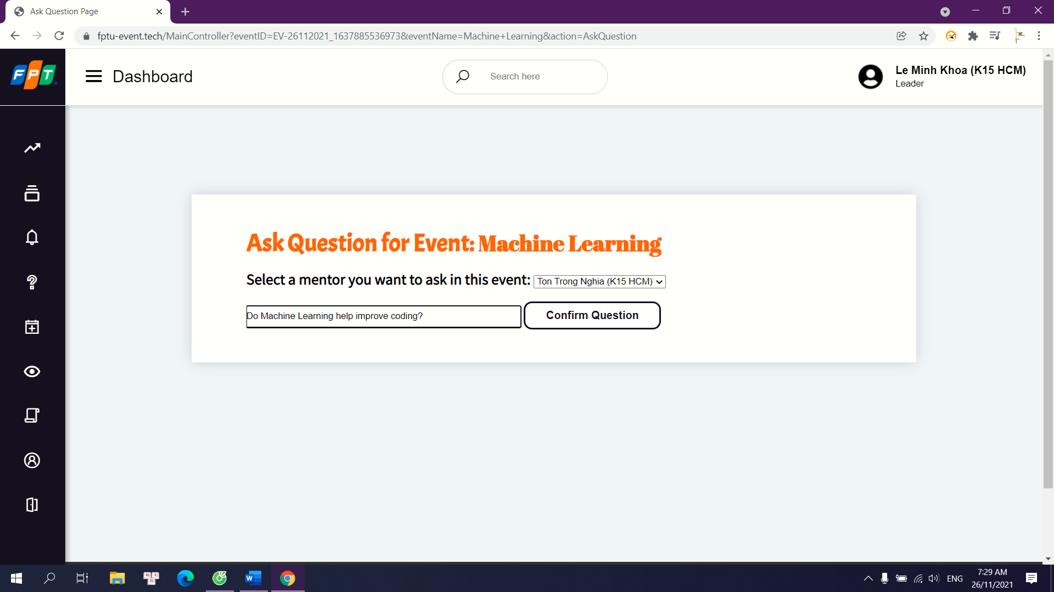

Details: system will use the input text as the question and the selection in combo box as mentor to ask. System will generation a new question in database will a null answer.

b. Answer Question

Trigger: when a mentor clicks “unanswered question” button.

Description: mentor can answer questions that other users ask. System will update the reply in database

Screen Layout:

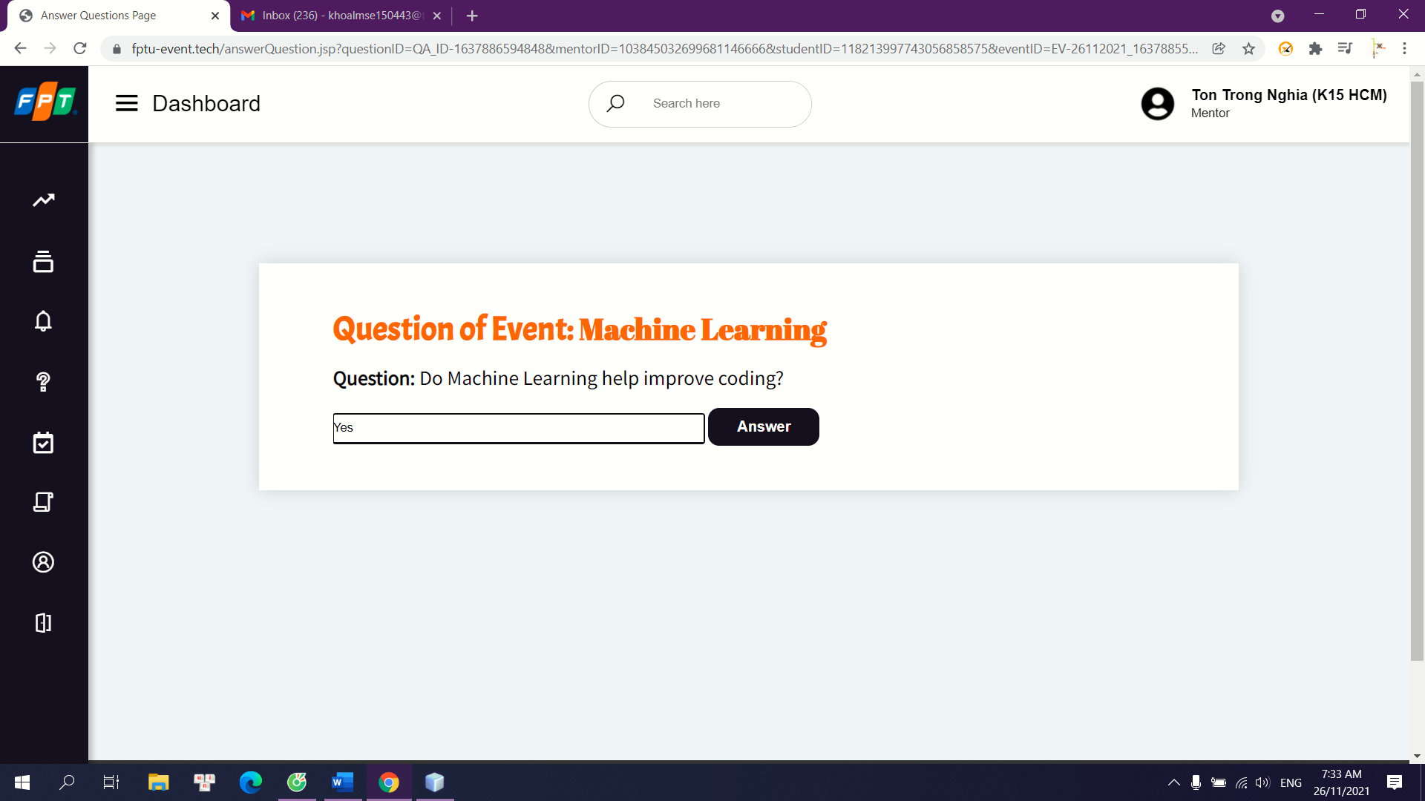

Details: system use input text as the answer. Mentor can review the answer in Answered Question page.

## 7. Change role

a. Request change role

Trigger: when a user clicks “change role” at Change Role page.

Description: if the account’s role does not match with user’s role, they can request to change their role.

Screen Layout:

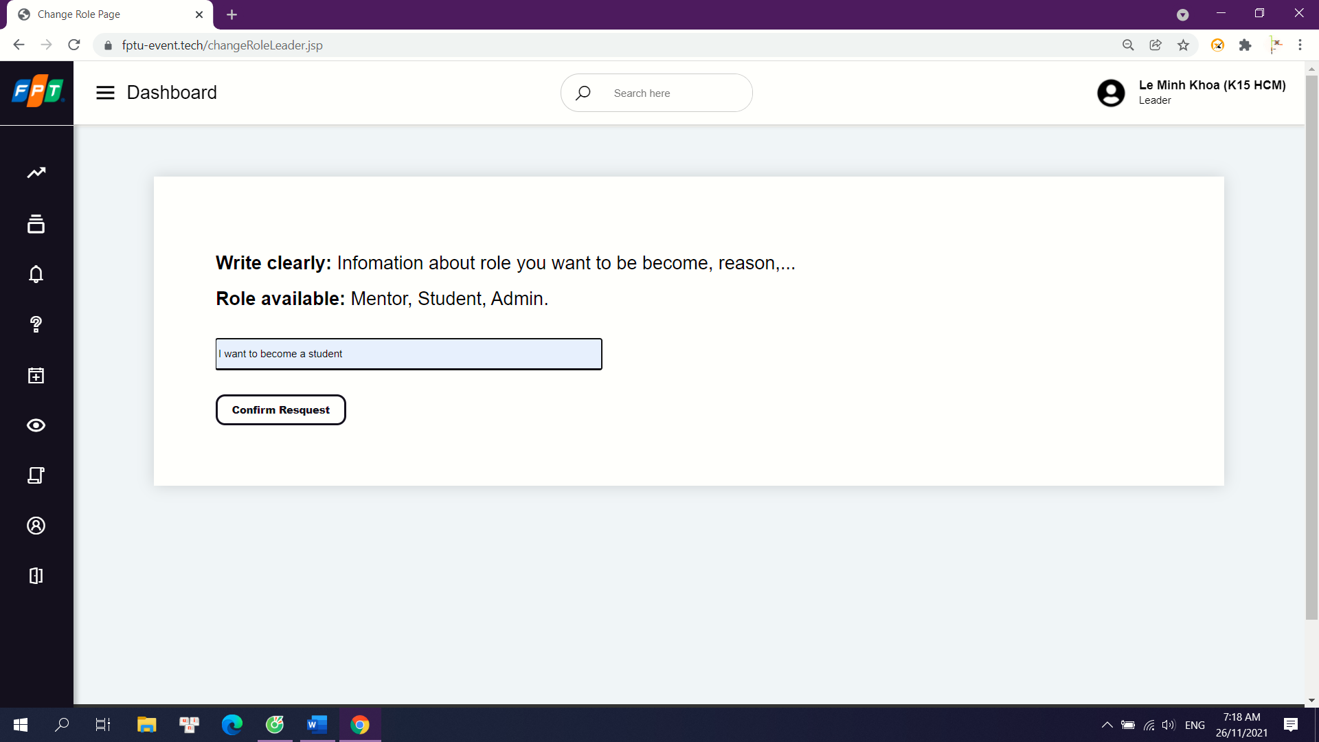

Details: After click “change role” button at home page, user can make a request to change their role. System will send an email with the input text as content for admin. They will consider if the role is wrong and change account’s role.

## 8. Event Management

a. Create Event

Trigger: when a user clicks “create” at Create Event page.

Description: Club’s Leader and Department’s Manager can create a new event with information like name, detail, seat, date start, date end…

Screen Layout:



Details: After click “create event” button at home page, user fill in the information for the new event and post it. The default status for new event is Upcoming.

b. Edit Event

Trigger: when a user clicks “edit event” button at Show List Event page.

Description: Club’s Leader and Department’s Manager can change the information of the events that was created by them.

Screen Layout:

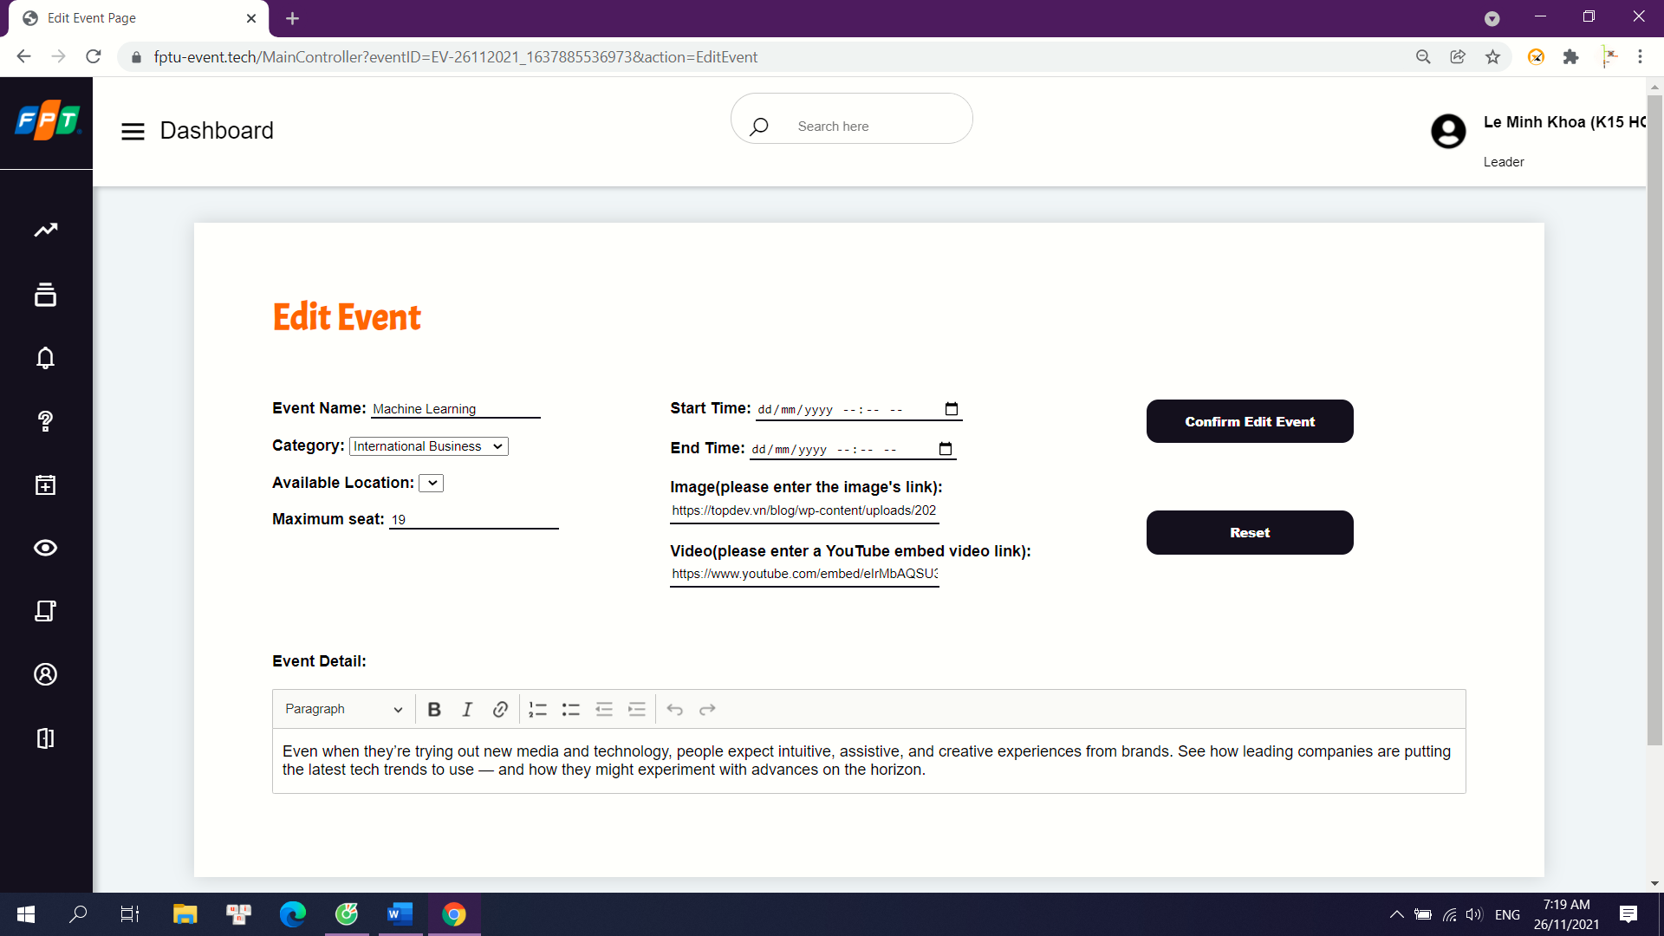

Details: After click “edit event” button at Show List Event page, user can change the information for the event they were created. System will send an email to notify for any user that followed it

c. Start Event

Trigger: when a user clicks “start event” button at Show List Event page.

Description: Club’s Leader and Department’s Manager can start events that was created by them.

Screen Layout:

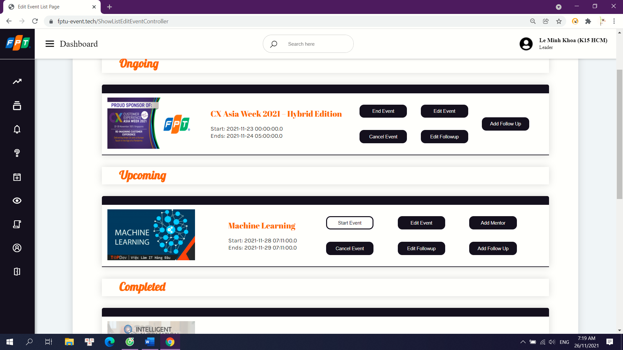

Details: After click “start event” button at Show List Event page, the event’s status will be come Ongoing. System will send an email to notify for any user that followed it.

d. Complete Event

Trigger: when a user clicks “end event” button at Show List Event page.

Description: Club’s Leader and Department’s Manager can complte ongoing events.

Screen Layout:

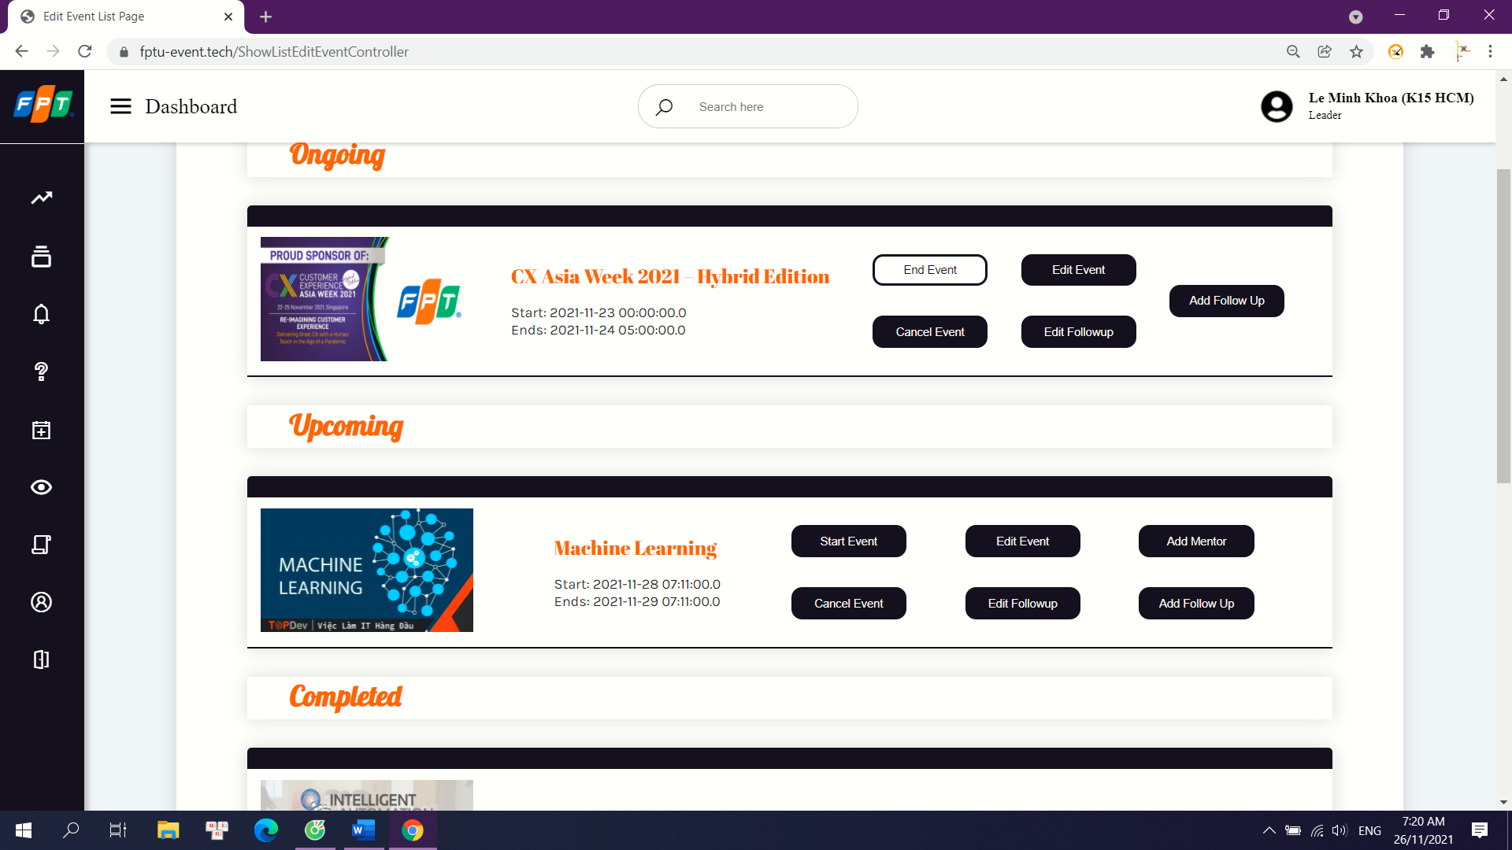

Details: After click “end event” button at Show List Event page, the event’s status will be come Complete.

e. Cancel Event

Trigger: when a user clicks “cancel event” button at Show List Event page.

Description: Club’s Leader and Department’s Manager can cancel events that was created by them.

Screen Layout:

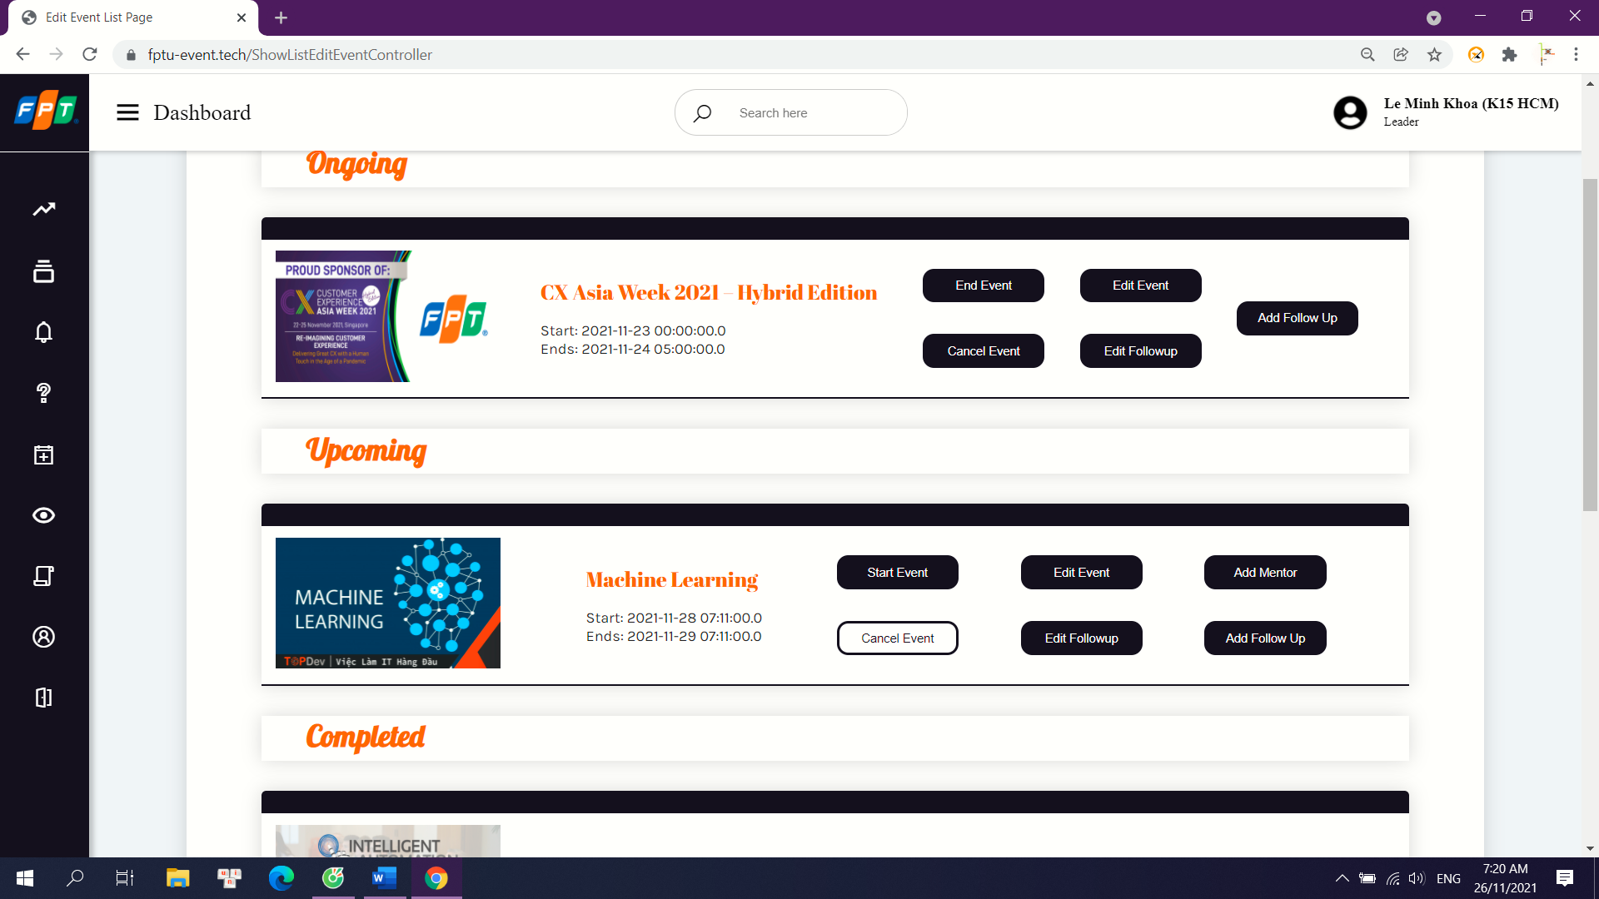

Details: After click “cancel event” button at Show List Event page, the event’s status will become Canceled. System will send an email to notify for any user that followed it.

## 9. Followup Management

a. Add Followup

Trigger: when a user clicks “add followup” button at Show List Edit Event page.

Description: Club’s Leader and Department’s Manager can add new followup for the event that they created.

Screen Layout:

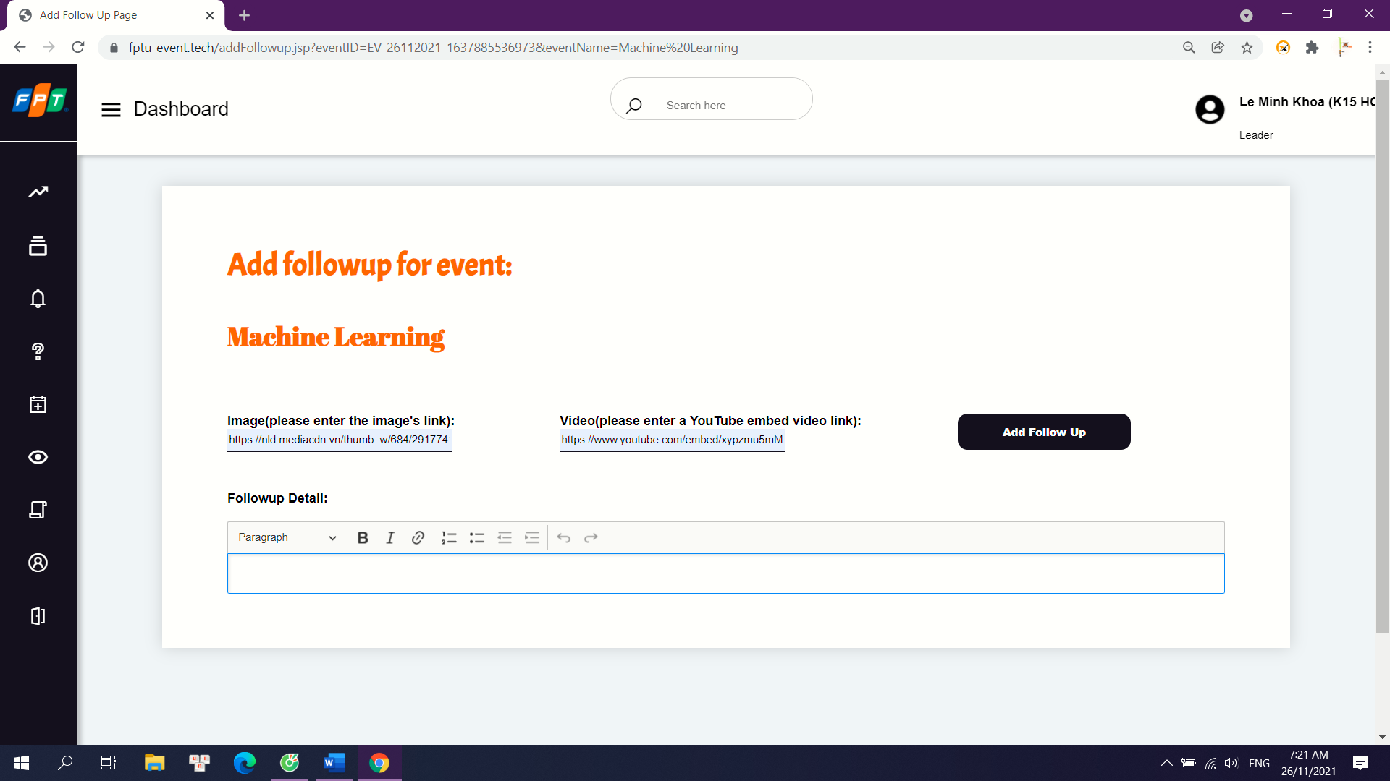

Details: After click “add followup” button at Show List Edit Event page, user fill in the information for the new followup and post it. System will send an email to notify for any user that followed the event.

b. Edit Followup

Trigger: when a user clicks “edit followup” button at Show List Event page.

Description: Club’s Leader and Department’s Manager can change the information of the followup that was created by them.

Screen Layout:

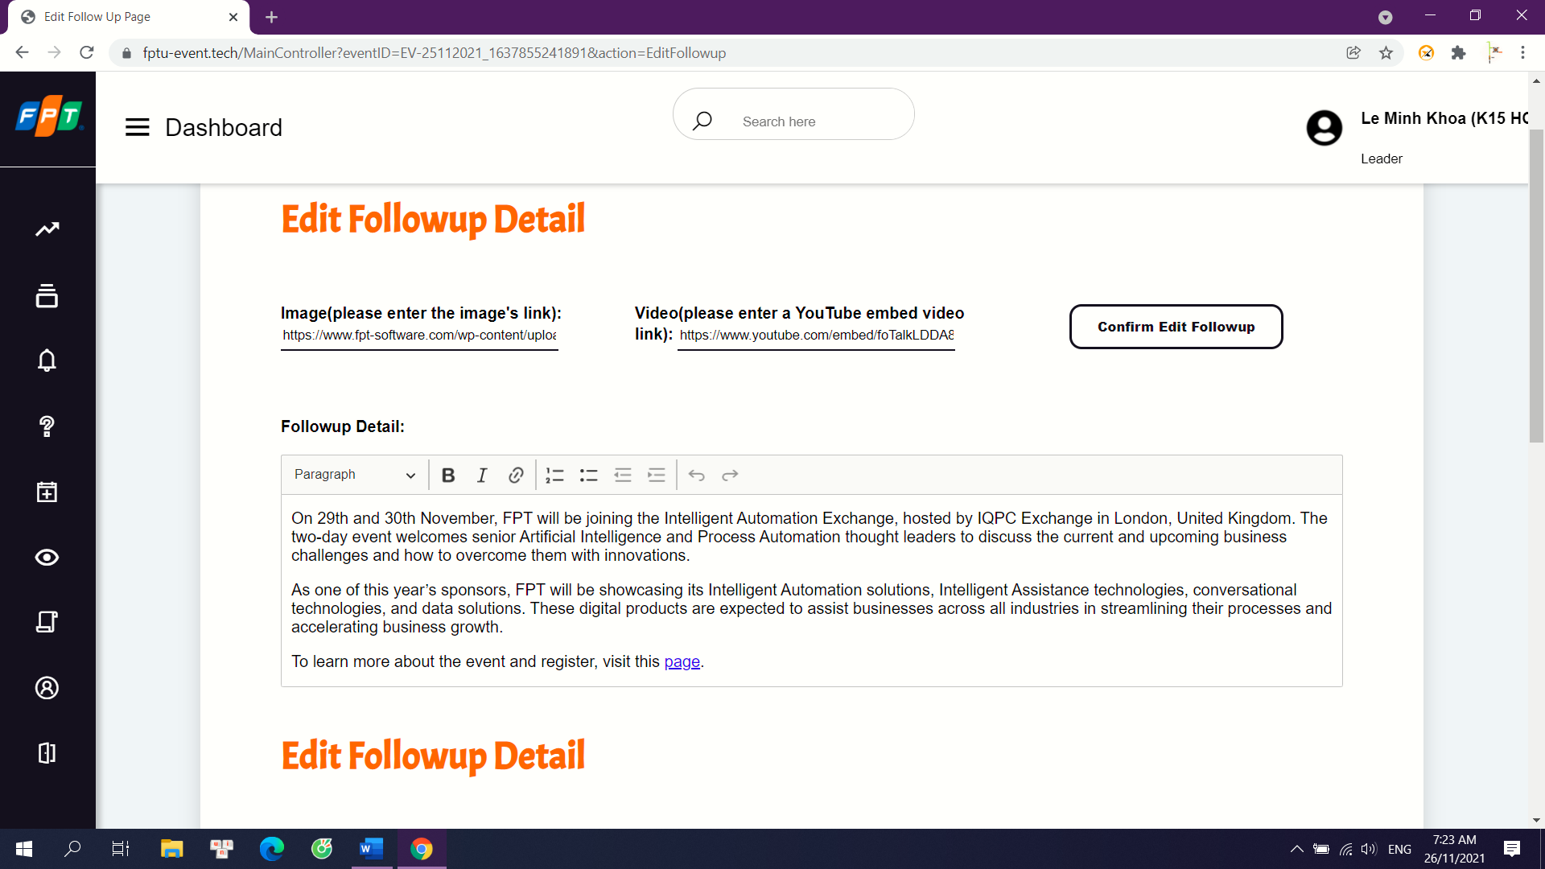

Details: After click “edit followup” button at Show List Event page, user can change the information for the followup they created. System will send an email to notify for any user that followed the event.

## 10. Mentor in Event Management

a. Add Mentor

Trigger: when a user clicks “confirm add mentor” button at Add Mentor page.

Description: Club’s Leader and Department’s Manager can add new mentor for the event that they created.

Screen Layout:

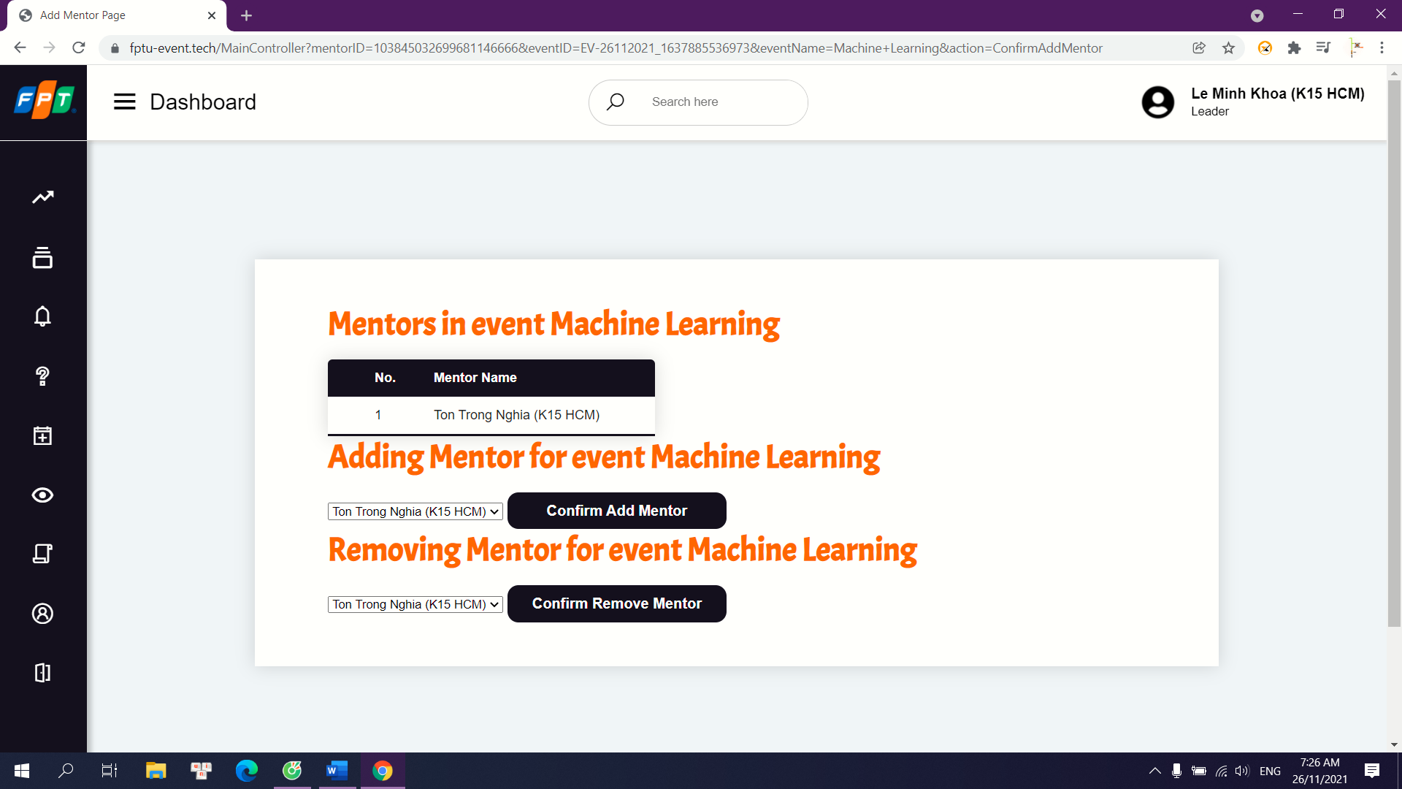

Details: After click “add mentor” button at Show List Event page, user can choose from a list of mentors to add into their event. System adds a new mentor to the event in database.

b. Remove Mentor

Trigger: when a user clicks “remove mentor” button at Add Mentor page.

Description: Club’s Leader and Department’s Manager can remove mentor that was added into the event that they created.

Screen Layout:

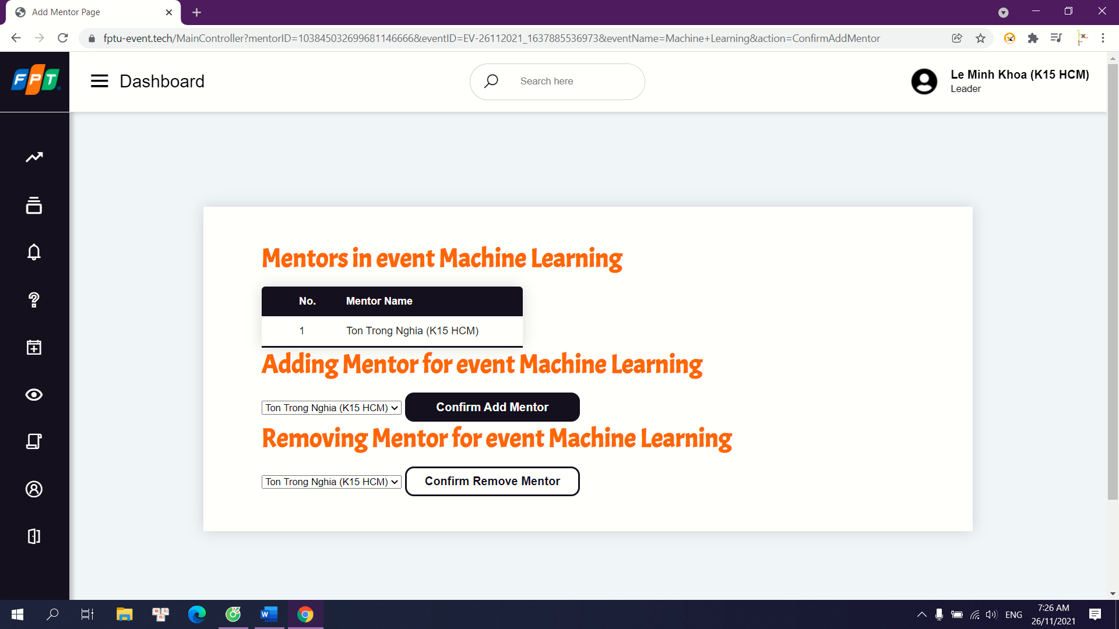

Details: After click “remove mentor” button at Show List Event page, user can choose from a list of mentors in their event to remove. System changes the status of the mentor in that event in database.

## 11. Particitpate in Event

a. Request Participate

Trigger: when a user clicks “join event” button at Event Detail page.

Description: Mentor can request to join an event

Screen Layout:

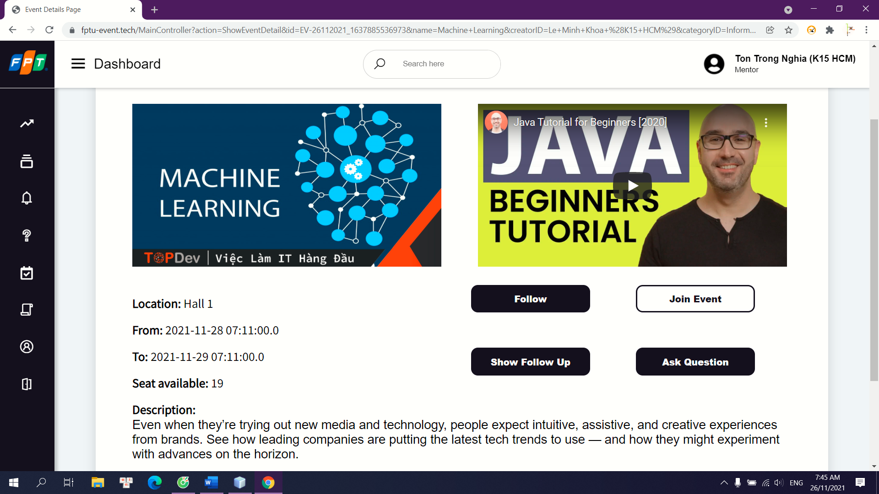

Details: After click “join event” button at Event Detail page, system will send an email to the creator of the event. They will decide if they want to add a new mentor to the event.

## 12. Account Management

a. Change information for account

Trigger: when a user clicks “update” button at Admin page.

Description: Admin can update information for account such as name, role.

Screen Layout:

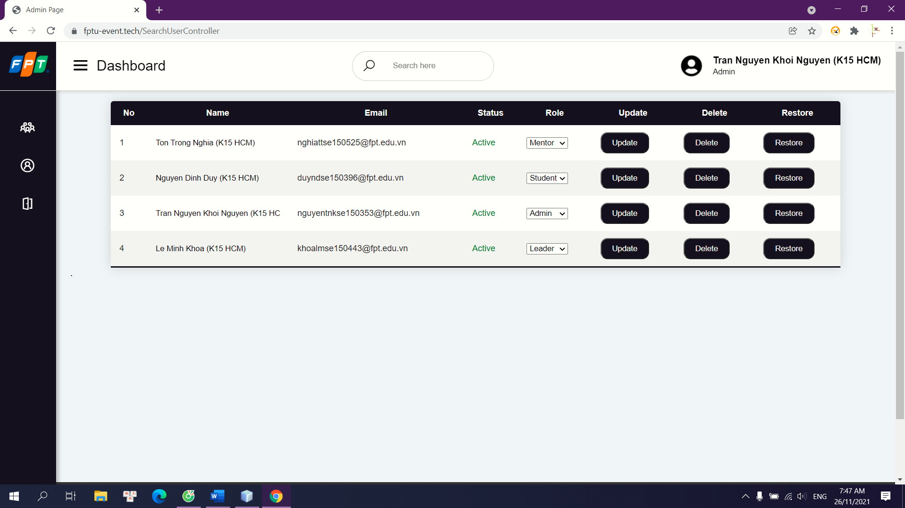

Details: After click “update” button at Admin page, system will update the information of that account in database.

b. Ban / Unban account

Trigger: when a user clicks “delete” / “restore” button at Admin page.

Description: Admin can ban / unban the account.

Screen Layout:



Details: After click “delete” / “restore” button at Admin page, system will update the status of that account in database to “deactive” / “active”.